2021 Fall Conference Information October 15-16, 2021

All events will be held in Detroit at the MotorCity Casino Conference Center. There will be complimentary parking for all attendees. Please see the parking map for instructions for parking closest to the conference center if you not staying at the hotel. You will use the Sound Stage Entrance. The Conference Center is a completely separate space from the casino.
APTA Michigan has a reduced rate room block for hotel reservations. Visit the conference website for details.

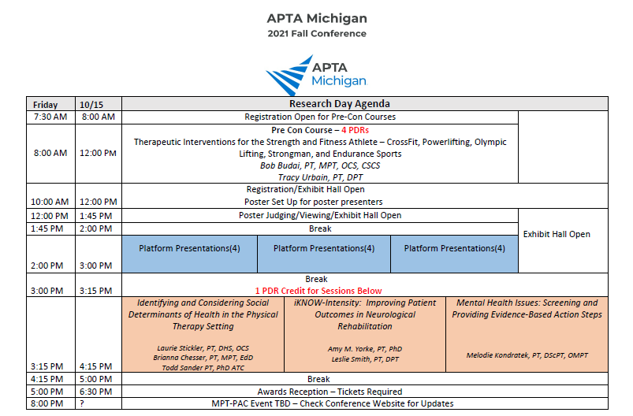
Attendees can earn up to 11.75 CEUs/PDR Credits during the conference – the schedule is below. The final sessions on Saturday have varying end times and will convey different CEUs based on time. Please note that we are offering Implicit Bias Training which will satisfy the new Michigan requirement for health care licensees.

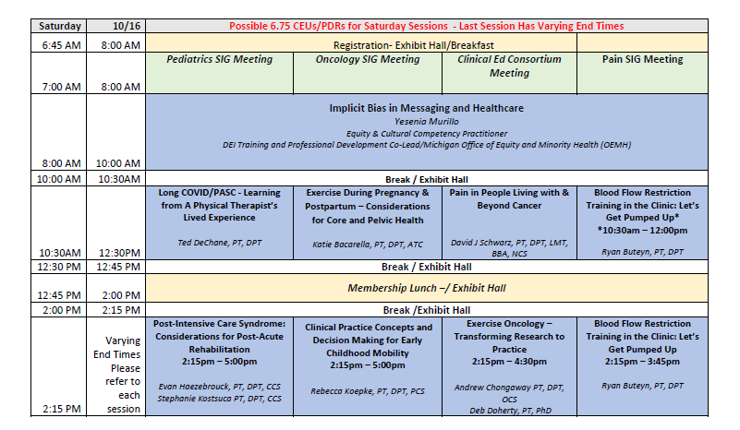

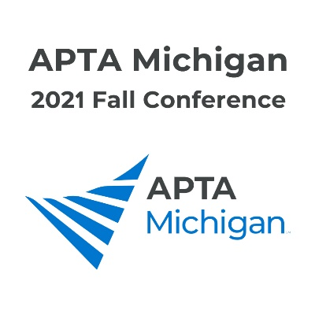
2021 Fall Conference Registration Form
*Precon CEUs: 4
Friday CEUs: EBP Session : 1
Saturday CEUs: 6 – 6.75
Total PDRs possible: 11.75 (*Precon is a separate registration)
MotorCity Casino – Detroit Early Bird Registration Deadline: October 1, 2021

Member Type | Full Conference*  Early Bird  (incl. Friday and Saturday) | Full Conference*  (after 10/1) | Fri 10/15  PM only  Early Bird | Fri 10/15  PM Only  (after 10/1) | Sat 10/16  Early Bird | Sat 10/16  (after 10/1)
PT Members | $175 | $260 | $30 | $45 | $150 | $225
PT Non-Members | $230 | $345 | $40 | $60 | $200 | $295
PTA Members | $130 | $195 | $25 | $40 | $110 | $165
PTA Non-Members | $180 | $270 | $35 | $50 | $150 | $225
Student Members | $95 | $145 | $20 | $30 | $80 | $120
Student Non-Members | $120 | $175 | $30 | $45 | $95 | $145
*Only Full Conference Registration includes the Awards Reception October 15
Note: Saturday and Full Conference Registrations include continental breakfast and seated lunch on Saturday
Additional Registration Options:
_____ Pre-Con Friday 8:00am-12:00pm: Therapeutic Interventions for the Strength and Fitness Athlete – Crossfit, Powerlifting, Strongman and Edurance Sports
Limited space. PT/PTA Members: $100 SPT/SPTA Members: $60
PT/PTA Non-Members: $140 SPT/SPTA Non-Members: $90
_____ Attend Awards Reception (Friday 10/15 5:00 – 6:30 pm) - $30 (Note this is included in Full Conference Reg)

Register Online
Cancellation policy: Full refunds will be allowed until 10/1/2021. Cancellation after that date will be non-refundable. Name substitutions will be allowed. *All confirmations will be sent via email unless otherwise requested. PHOTO DISCLAIMER: Please be aware that this registration form also serves as an agreement to appear in photographs taken at the 2021 MPTA Fall Conference. And that these photos may be used for publicity or general information purposes and may be seen by the general public. Questions? Email the APTA Michigan office at contact@aptami.org or call 517-234-5040
Conference handouts will be available in the conference mobile app before and during the conference. No handouts will be available at the conference.

