APTA Michigan 2020 Virtual Fall Conference
Saturday, October 10 8am – 3pm

Conference Sessions
8:00am – 10:00am – All attendees

Working Towards Health Equity and Justice Within the World of Rehabilitation
Within Michigan and around the world, the current offer of rehabilitation services is inadequate and inequitably distributed. Per the APTA’s code of ethics, physical therapists are obliged to work towards reducing health disparities and health care inequities. Case scenarios on current issues like COVID-19 and race will be utilized in this course to explore issues related to equity and justice specific to the physical therapist. Small breakout sessions will facilitate participants to discuss difficult questions like how am I contributing to the development or maintenance of inequities within rehabilitation and what practical actions can I take to work towards justice?

April Gamble PT, DPT, CLT is a licensed physical therapist who earned her Doctorate of Physical Therapy in Michigan, USA. She has developed a global health expertise with a special interest in collaborating with local providers to develop rehabilitation services for underserved populations. April is the CEO of ACR - The American Center for Rehabilitation which is based in Kurdistan, Iraq. In this role she leads the development of equitable rehabilitation services in both private and public sectors and in a manner that meets the needs of the diverse communities in Kurdistan. April also regularly consults with various local NGOS and international NGOs including Heartland Alliance International, Humanity and Inclusion, and DIGNITY – Danish Institute Against Torture in order to develop rehabilitation and mental health services for survivors of torture and war trauma in prisons, detention centers, community clinics, and refugee camps. Additionally, she is the 2019 recipient of the International Association for the Study of Pain’s Developing Countries grant which will result in over 250 Kurdish physiotherapists being equipped with the skills and knowledge to treat pain from a biopsychosocial approach.

April currently serves as secretary for the Health Policy and Administration Section (HPA) Global Health Special Interest Group and the chair for the Global Outreach Committee of the APTA Michigan Oncology Rehabilitation Special Interest Group. April’s publication credits include textbook chapters in international texts and articles in peer reviewed international journals. She has delivered a variety of presentations at national and international meetings including the WCPT Congress (2015, 2017, 2019) and APTA’s annual conferences (2017, 2019, 2020). April’s current research and advocacy interests involve advancing services globally for vulnerable populations that are under-assessed and under-treated.

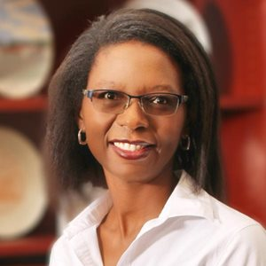
Prisca M. Collins, PT, PhD is an associate professor and Director of Community engagement in the School of Physical Therapy at Florida Southern College (FSC). She holds a PhD in Rehabilitation Sciences with a focus on Policy, Organization and Management Studies. Dr Collins is a licensed physical therapist with over 20 years of clinical experience. Her teaching expertise is in psychosocial aspects of physical therapy, evidence-based practice, and physical therapy administration. Her research is focused on the use of community-based participatory approaches to address psychosocial factors that predispose individuals to developing chronic health disorders; and improving accessibility of healthcare services for underserved populations. Currently she is principal investigator for a project utilizing physical activity to promote healthy weight and healthy blood pressure among under-insured and non-insured residents of Polk County, FL; funded by the Florida Physical Association Catherine E. Patla community awareness grant.
Dr Collins has worked internationally as a physical therapist in Botswana and participated in a medical mission to Zimbabwe through her local church. She served as a member of the Illinois Physical Therapy Association (IPTA) Research Awareness and Support Committee, and on the IPTA Continuing Education committee. She currently serves as a member of the nominating committee of the Health Policy Administration Section (HPA) - Global Health Special Interest Group. She has published scholarly articles on the training of culturally responsive evaluators committed to social change & social justice; disparities in PT & OT workforce distribution; and effectiveness of mechanical traction for the management of cervical radiculopathy.

10:15am – 12:15pm Concurrent Sessions

Building a P.T. Business – Thriving in the Good Times, and Surviving the Tough Times
Opening and running a Physical Therapy business presents various challenges. Guidance on the details required from opening, through the various stages of operating and growing the business, and eventually coming up with an appropriate exit strategy; is information that can be useful, not only to business owners, but to everyone taking part in business operations on all levels.

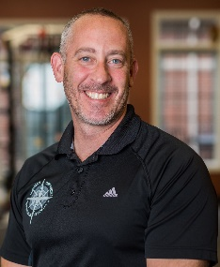
Bob Budai, PT, MPT, OCS, CSCS opened Michigan Orthopedic Rehabilitation Specialists in 2015, after serving as physical therapist and clinic director for multiple orthopedic private practices. Prior to opening MORS, Bob started Functional Strength Training in 2006 to help people of all levels achieve higher levels of fitness. In 2017, he began Medical Fitness of Michigan – a comprehensive program designed to bridge the gap between his Physical Therapy and fitness clients.
Bob has taught various courses, and consulted on topics of exercise, evaluation, and manual techniques for multiple colleges and professional organizations. By combining elements of his various businesses with his experience and education; Bob has been able to create a team of professionals that have helped people improve their bodies and quality of life for over 20 years.

Brian Adams, PT, DPT, OCS, CSCS founded Adams Sports Medicine & Physical Therapy in 2013 with a mission to offer endurance athletes the best possible treatment and training to help them feel better, get faster, and go farther.
The Novi resident is an elite-level cyclist with more than two decades of experience racing, wrenching, and fitting. He’s also an accomplished swimmer and triathlete who enjoys soccer and rock climbing. By merging his knowledge of sports and physical therapy, Brian has come to occupy a unique space in the PT field. Before creating Adams Sports Medicine & Physical Therapy, Brian spent more than 15 years working at the University of Michigan Sports Medicine Department as a clinician and a supervisor. He has a vast amount of experience with shoulder and knee diagnoses, acute injuries, post-operative care, and return-to-sport conditioning. He’s also an Adjunct Clinical Lecturer in the PT Department at the University of Michigan-Flint, as well as a regular lecturer at conferences and events on topics pertaining to injury treatment and prevention in athletes

Red Light, Green Light: How to Steer Through the CPG to Improve Locomotor Function
The Clinical Practice Guideline (CPG) to Improve Locomotor Function Following Chronic Stroke, Incomplete Spinal Cord Injury, and Brain Injury was published early in 2020 in the Journal of Neurologic Physical Therapy. The CPG makes several recommendations for best physical therapy practice. However, the document is 51 pages in length making it difficult to digest. The speakers will demystify the CPG and assist clinicians in applying the action statements into their practice and addressing barriers to implementing. Authors will use videos to assist in demonstration of knowledge translation practices audience members can take back to their clinic.

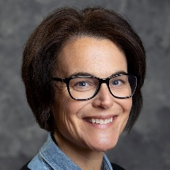
Amy Yorke, PT, PhD, NCS is an Associate Professor in the Physical Therapy Department at the University of Michigan-Flint. As the team lead of the Integrating KNOWledge Translation (iKNOW) lab, Dr. Yorke research interests are in translating evidence based practices to clinical, community, and academic settings. In addition, Dr. Yorke is interested in further understanding interprofessional collaborative practice in both education and in the clinic.

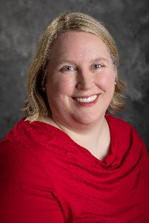
Suzanne Trojanowski, PT, DPT, NCS is an Assistant Clinical Professor in the Physical Therapy Department at the University of Michigan Flint. She received her entry-level Masters degree in Physical Therapy from Ithaca College and went on to complete a post-professional Doctorate of Physical Therapy from Virginia Commonwealth University. Dr. Trojanowski is also a board-certified clinical specialist in Neurologic Physical Therapy. Her clinical background is in both acute care and inpatient rehabilitation with expertise in stroke and acquired brain injury. Her research interest is in knowledge translation and interprofessional education

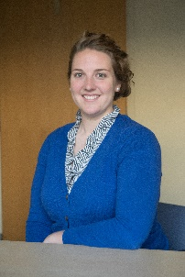
Nora Fritz, PT, DPT, PhD, NCS is an Assistant Professor of Physical Therapy and Neurology at Wayne State University. She directs the Neuroimaging and Neurorehabilitation Laboratory and is interested in developing novel interventions to improve mobility and function in persons with Neurologic disorders. She is committed to the development of Clinical Practice Guidelines, and has contributed to the recently published Locomotor CPG, led an international effort to develop a CPG for Exercise in Huntington's Disease which was published in 2020 and is currently working with the Academy of Neurologic Physical Therapy to develop a CPG for Balance and Falls in Neurologic populations.

The Role of Lab Values and Vital Signs in Clinical Decision Making and Patient Safety for the Acutely Ill Patient
This will review why lab values and vital signs such as hemoglobin, potassium, glucose, blood pressure, heart rate and others are essential clinical tools to determine appropriateness for rehab interventions of acutely ill patients. Normal and abnormal values, as well as steps clinicians can take to monitor the patient’s response will be discussed. Finally, patient care case studies specific to the geriatric population will be presented and are designed to help the learner problem solve and improve clinical decision making related to labs and vitals.

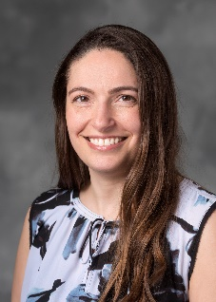
Adele Myszenski, PT, MPT is a supervisor at Henry Ford Hospital in Detroit, MI, a level 1 trauma, academic hospital. A 2001 graduate of Wayne State University and currently enrolled in WSU’s tDPT program class of 2021, Adele has led initiatives to expand value-based services of PT and OT and since 2015 has included a two-fold growth in staff positions, creation of new pathways including the nation’s first structural heart PT and OT pathway and an early rehab program that now serves over 200 ICU beds across the system. Adele and the early rehab team received the 2019 Crain's Healthcare Detroit Healthcare Heroes distinction. She is responsible for creation, development and implementation of competencies across the service line for lab values, ICU, VAD and other areas and is the expert superuser and chair for EPIC and allied health site leader for CPM Elsevier at HFHS. In addition, Adele serves the APTA on the PTNow committee and is an accomplished speaker providing sessions at APTA’s CSM for 6 years, MPTA conferences and APTA State Forum, as well as webinars for PT.com, OT.com and PTLocker via MPTA. Adele has a passion for the acute care patient, particularly those in critical care, both adult and neonatal ICUs. Her areas of research include lab values, critical care, structural heart, functional outcome measures and value based therapy.

Note: This Session is 3 hours: 10:15am – 12:15pm then 1:00pm – 2:00pm
The Athlete’s Hip: Simplifying the Evaluation, Treatment, and Return to Sport of Athletic Groin Pain
The evaluation and rehabilitation of hip injuries in the athlete is a complicated and often misunderstood area of sports medicine. Over the course of the past five years, significant strides have been made in adding some clarity, and in some cases adding to confusion, of diagnosis and treatment of athletic groin pain. We will take you through an evidence-based evaluation of groin injuries with an emphasis on femoroacetabular impingement syndrome and athletic pubalgia. By understanding the current literature, you will be better able to simplify your evaluation and clinical reasoning when an athlete presents with groin pain.
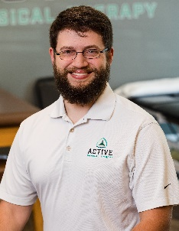
John Snyder, PT, DPT, OCS, CSCS, has worked in various outpatient orthopedic and sports medicine environments, but specializes in the treatment of athletes with hip pain and more specifically ice hockey athletes. He earned a Bachelor of Science in Exercise Science degree from Youngstown State University and a Doctor of Physical Therapy degree from the University of Pittsburgh.

After practicing for several years, he became board certified as an Orthopaedic Clinical Specialist and Certified Strength & Conditioning Specialist. He currently manages a private practice in Columbus, Ohio that caters to an athletic patient population. When not treating patients, he lectures nationally and internationally on topics focused on the management of The Athlete’s Hip and The Ice Hockey Athlete and manages his website (JohnSnyderDPT.com) that provides educational material for physical therapists, athletic trainers, and other allied health professions.

1:00pm – 3:00pm Concurrent Sessions

Relative Energy Deficiency in Sport (RED-S): A Role for Physical Therapists
Relative energy deficiency in sport (RED-S) has evolved from an issue believed to be experienced only by females with eating disorders, to one impacting any athlete on a spectrum of energy-deficient states. The combination of limited energy availability, hormonal dysfunction, and poor bone health create both short and long-term consequences on performance and health for many female athletes. These include
impairments in performance, bone stress injuries, and increased risk of fractures with aging. With young athletes facing increasing familial and societal pressure to exceed athletically, this issue is prominent and crucial to address. The purpose of this presentation is to describe the broad-spectrum RED-S, discuss recognition of risk factors and identification of the components, and provide evidence for physical therapy intervention as part of a multidisciplinary treatment approach in this population. This platform is an opportunity to provide information on the role of the physical therapist in participating in the evaluation and treatment of this population, in the hopes of improving both short and long-term outcomes for these athletes.
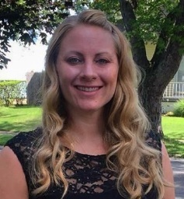
Laura Fisher PT, DPT, PhD, OCS graduated from Hardin Simmons University with her Doctorate of Physical Therapy in 2008. She graduated from the University of Michigan Health Systems Orthopedic Residency in 2011 and obtained her OCS in 2012. Laura received her PhD in Orthopaedic and Sport Science from Rocky Mountain University of Health Professions in 2018. She is a clinical specialist at Michigan Medicine and the director of Michigan Medicine Orthopedic Residency Program. Laura teaches several topics and leads the residency research projects in the Michigan Medicine orthopedic residency program.
Laura has also presented at the Michigan Physical Therapy Annual Conference and Combined Sections Meeting. She has had numerous poster presentations at the Texas Physical Therapy Association, Michigan Physical Therapy Association, and APTA Combined Sections Meeting. Her clinical interests include orthopedic spinal conditions, thoracic spine and rib cage, and hypermobility

Stephanie Mundt PT, DPT, OCS, CSCS is a physical therapist and lifelong runner who personally experienced RED-S and its subsequent impact on injury and health. She graduated from the University of Southern California with a Doctorate of Physical Therapy in 2017, then completed an Orthopedic Residency at Michigan Medicine in 2018 and obtained her OCS in 2019.
She started Volante Physical Therapy & Performance in Scottsdale, AZ in spring 2020, offering physical therapy and run coaching services to runners of all levels. Her aim is to provide individualized, high-quality care to empower runners to continue running for life.

Prevention Focused Home-Based Physical Therapy Utilizing Community Partnership Referrals
While traditional home health care (HHC) reimbursement models emphasize intervention after a medical or functional decline occurs, there is a role for preventative home-based physical therapy services for those at highest risk of becoming home-bound due to illness, injury, or functional limitation. The purpose of this educational session is to describe the implementation and initial results of a primary/secondary prevention clinical practice model administered by physical therapists (PTs) in partnership with a community referral partner. Oakland University has done substantial research and implementation to provide early preventative interventions to senior citizens at risk of being homebound by facilitating partnerships between local senior community centers and PTs. Three key aims of prevention-PT programs include: 1) Establishing partnerships between senior community centers and PTs to provide direct referrals to preventative physical therapy services, 2) Leveraging the skills and knowledge of a PT to provide a bridge between the local community and the medical system, and 3) Providing a strong body of evidence demonstrating the value of integrating prevention-PT programs into the standard of care for aging adults.

This educational program will provide supportive evidence for initiating prevention focused-PT programs for older adults, addressing common age-related risk factors using a primary/ secondary prevention approach, and funding a scalable home-based prevention program. Additionally, the program protocol, inclusive of its unique referral mechanism will be detailed. Valid and reliable pretest- posttest outcome assessments and the associated interventions related to the individual’s health behaviors, home environment safety, and associated fall risk using will be outlined.

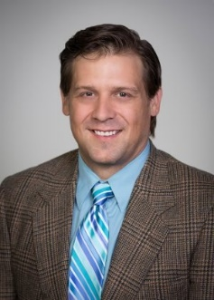
Chris Wilson, PT, DPT, DScPT is an Assistant Professor at Oakland University. He is board certified in geriatric physical therapy. His clinical practice is in cancer physical therapy and acute care. Dr. Wilson’s research agenda focuses on palliative care physical therapy and the management of late-stage chronic illnesses. He teaches geriatrics, pharmacology, biophysical agents, and acute care in Oakland University’s Physical Therapy Program. He is co-principal and co-founder of HOP-UP-PT, LLC.

Chris received his Doctor of Science in Physical Therapy from Oakland University in 2015. He received his transitional Doctor in Physical Therapy from University of St. Augustine with a Primary Care Certification and his Masters in Physical Therapy from Oakland University in 2001. In the past, Chris has served the professional community as an Item Writer for the PT National Licensure Examination.

Chris was honored by the American Physical Therapy Association (APTA) with the APTA Emerging Leader Award in 2009 and the Signe Brunnström Award for Excellence in Clinical Teaching in 2015. Dr. Wilson has served the physical therapy professional association at global, national, state, and local levels. Dr. Wilson successfully authored and coordinated passage of motions outlining the APTA’s position on PT’s Role in Hospice and Palliative Care, the PTs Role in Diet and Nutrition, and the PT’s Role in Safe Patient Handling. He is active in clinical research in the areas of Hospice/Palliative Care and Safe Patient Handling and Mobility.

Sarah Arena, PT, DScPT is an Associate Professor in the Physical Therapy Program at Oakland University. She received her entry level physical therapy degree from Grand Valley State University, a Master’s of Science in Exercise Science and then a Doctor of Science in Physical Therapy with a certificate in Teaching and Learning from Oakland University.
Her teaching and research efforts focus on health promotion and wellness among community dwelling and home-bound individuals with an emphasis on blood pressure measurement. Additionally, she continues her clinical practice as a home health care physical therapist with Henry Ford Home Health Care. She is co-principal and co-founder of HOP-UP-PT, LLC.
Dr. Arena’s professional awards include the Michigan Physical Therapy Association (MPTA) Outstanding Clinical Instructor Award, the APTA Award for Clinical Excellence in Acute Care, the Michigan Home Care Association Certified Hospice Outstanding Service Award, the Jane Walters Award for Educational Excellence, the MPTA Outstanding Professional Poster Presentation, the APTA-Cardiopulmonary Section Award for best professional platform presentation.

Continued on next page

Prehabilitation: Medical, Psychological, and Physical Patient Optimization
Prehabilitation is a proven strategy to maximize clinical outcomes following surgery. In this presentation, Dr. Scott Russo and Holly Lookabaugh-Deur describe the complex puzzle of utilizing an individual approach to preparing patients for a successful surgery - medically, physically, including nutritional optimization, and psychologically. The entire medical team has a role in facilitating patient engagement in managing their own health.

Holly Lookabaugh-Deur, PT, DSc, GCS, CEEAA is a physical therapist with an educational background of a BS at the University of Connecticut, MHS from Grand Valley State University, and DSc from Rocky Mountain University of Health Sciences. A board certified geriatric physical therapist, Holly holds certifications in aquatic therapy, edema management, LSVT Big, wound care, exercise expert for aging adults, and oncology care. With 40 years of clinical practice, administrative and educational service, she serves as an adjunct instructor in 5 PT programs and has authored multiple continuing education programs and is an instructor in the CAPTCC Aquatic Certificate program. She is currently the VP of the MPTA's Oncology SIG. Clinical specialty interests include aquatic therapy, oncology care, fall prevention, concussion management and interdisciplinary care across all settings.

Scott Russo, MD specializes in the surgical and non-surgical treatment of spinal disorders and orthopaedic fracture care. He is accomplished in all areas of cervical, thoracic and lumbar spinal surgeries, including trauma, tumors, degenerative conditions, scoliosis and herniated discs. His subspecialty of interest is in the non-surgical and surgical care of pediatric and adult scoliosis and kyphosis. Dr. Russo is also part of the clinical faculty at Grand Valley State University, Michigan State University College of Human Medicine and the coordinator for the spine in the Grand Rapids Orthopaedic Residency Program.

Note: This Session is 1 hour: 2:00pm – 3:00pm
Complete Rehabilitation for the Overhead Throwing Athlete
Brief Description: The injury epidemic in throwing athletes is well known but less known are the often dismal return play to rates. Getting athletes back on the field to stay requires assessment techniques that allow clinicians to identify impairments and potential compensatory patterns that can be correlated to a motion capture biomechanical analysis to discover how and why an athlete may recruit velocity in a specific sequence. In this presentation we will use common case-based examples to demonstrate how an athlete can be progressed through a corrective exercise and motor learning progression to move towards biomechanical efficiency and full rehabilitation.

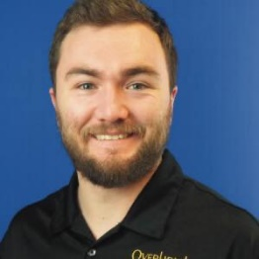
Max Wardell, SPT, BS, CSCS, CAFS is the Director of Throwing at the Overhead Athletic Institute. He is currently completing his Doctorate of Physical Therapy at Oakland University. After pitching collegiately for the Concordia University Ann Arbor, he transferred to Oakland University where he completed his Bachelor of Science in Health Sciences with a concentration on Exercise Science. Max completed a 3 year apprenticeship under Ed Martel, the founder of the Overhead Athletic Institute, orthopedic physical therapist, and former professional pitcher. With Ed Martel MPT, OMPT, Max has co-authored the book Rehab to Throw Like a Pro: The Clinician's Guide. Additionally, Max is a Certified Strength and Conditioning Specialist through the NSCA and a Certified Speed and Agility Coach through the NSPA. Max also holds a certification in Applied Functional Science through the Gray Institute.

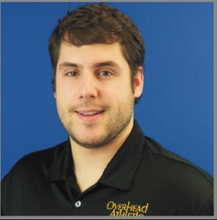
Kyle Suminksi PT, DPT is an OAI Certified Physical Therapist and former collegiate outfielder playing 4 years at Ohio Dominican University where he earned a Bachelor of Science in Exercise Science. He earned his Doctor of Physical Therapy from Grand Valley State University. Kyle also currently coaches youth federation (travel) baseball. Kyle specializes in rehabilitation of injured throwing athletes.

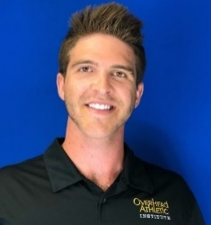
Carter Kovalcik SPT, BS, PES is an OAI Certified Throwing Instructor and OAI Certified Trainer having 12 years of mentoring experience under the founder of the Overhead Athletic Institute and former professional pitcher, Ed Martel MPT, OMPT. He is a Doctor of Physical Therapy student at Oakland University. Carter pitched at the NCAA Division 1 collegiate level at North Carolina Central University where he earned a Bachelor of Science in Exercise Science. Carter is also certified through the National Academy of Sports Medicine as a Performance Enhancement Specialist (PES). Carter specializes in performance training and throwing biomechanics.

