**Student Conclave Schedule**

**Friday March 26, 2021**

**Start End**

|  |  |  |  |
| --- | --- | --- | --- |
| **8:00** | **8:30** | **Career Fair** | |
| **8:30** | **9:00** | **Opening Remarks and Keynote** | |
| **9:00** | **10:00** | **Let’s Play Impact or Fiction the Concussion Discussion!** *Karley Glashauser, PT, DPT, CBSI, CCI, SCCE, CF-L1, Hippotherapy Trained* | **Physical Therapy Across the Oncology Continuum**  *Deb Doherty, PT, PhD*  *Lori Boright PT, DPT, DScPT* |
| **10:00** | **10:30** | **Career Fair/Break** | |
| **10:30** | **11:30** | **Workshop: Guided Tour of Four Important Financial Topics** *David Cushard, ChFC, CMFC* | **Diastasis Rectus Abdominis: Principles over Protocols**  *Emily Wilson PT, DPT* |
| **11:30** | **12:30** | **Career Fair/Lunch** | |
| **12:30** | **1:30** | **Physical Therapy in the Emergency Center**  *Courtney Witczak, PT, DPT, GCS* | **Beyond Clinic Walls: Providing Practical Therapy in the Community**  *Steven Mandley, PT, CBIS* |
| **1:30** | **1:40** | **Break** | |
| **1:40** | **2:00** | **Closing Remarks and Prizes** | |
| **2:00** | **2:30** | **Scheduled Roundtables and Interviews** | |

**Student Conclave Course Decriptions**

**Let’s Play Impact or Fiction the Concussion Discussion!**

In this course, we will take a journey through the mind… literally. We will have an interactive discussion to dispel myths related to concussion and concussion treatment. We will discuss the pathophysiology behind concussions, Physical Therapy treatments related to acute concussion, Treatment for Post-Concussion Syndrome, Importance of Baseline testing, and Return to Play Protocols. Exercise with concussion, don’t knock it til ya try it!

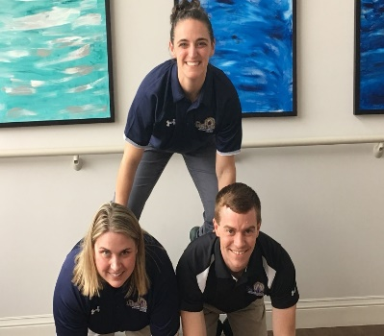

Speaker: Karley Glashauser, PT, DPT, CBIS,CCI, SCCE, CF-L1

Hippotherapy Trained, CrossFit Level 1 Trainer

Karley graduated with her Bachelor’s Degree from Central Michigan University in 2006 with a Major in Health Fitness in Preventative and Rehabilitative Programs with a double Minor in Psychology and General Science. She then continued on to graduate with her Doctorate of Physical Therapy from Central Michigan University in May of 2009. Karley has been employed at The Lighthouse, Caro location, since July of 2009. Karley is a Certified Brain Injury Specialist (CBIS) and has continued education in the areas of Hippotherapy, NDT, and Concussion Management. Karley believes in furthering the future of the Physical Therapy profession and as so takes interns and function as a Clinical Instructor as well as works closely with the Universities as the Site Coordinator of Clinical Education at Caro location. Karley believes in practicing what she preaches so she leads a very active lifestyle and has been an active member of the CrossFit community for over 6 years. Karley is married and has two young boys who also keep her on the go. Karley is passionate about neurological rehabilitation, children, and sports athletes culminating her involvement in implementing a Concussion Management Program here at the Lighthouse.

**Physical Therapy Across the Oncology Continuum**

Oncologic physical therapy is a rapidly growing domain in the profession, and regardless of your future clinical specialty, you will encounter patients with a history of cancer.  The information in this presentation is paramount to effectively and holistically treat your future patients.  The focus of this presentation will encompass the physical therapy interventions to treat the adverse effects resultant of medical management throughout the continuum of care.

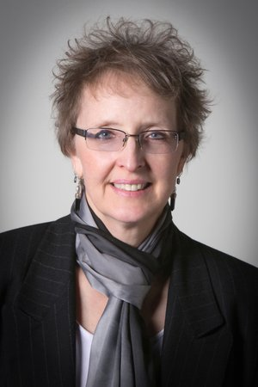Speaker 1: Dr Deb Doherty PT, PhD

Deborah Doherty is the Chairperson of the Human Movement Science Department in the School of Health Sciences and an Associate Professor in the Physical Therapy Program at Oakland University. She is an advanced practitioner in the treatment of patients diagnosed with cancer. Dr. Doherty co-developed the first international online Graduate Certificate for Oncology Rehabilitation Program at Oakland University for physical therapists which began fall of 2012. She developed the Comprehensive Oncology Rehabilitation Program at St. Mary’s of Michigan in Saginaw Michigan and Hills and Dales Hospital in Cass City, Michigan. Her research focus is on Oncology Rehabilitation with an emphasis on Survivorship Programs and Prehabilitation. She is serving as the Michigan Physical Therapy Association representative for the Michigan Cancer Consortium serving as Co-Chair of the Board, as well as serving as a member of the membership committee, serving as the Survivorship Workgroup Chairperson. Dr. Doherty championed the development of the Oncology Rehabilitation Special Interest Group for the Michigan Physical Therapy Association and now serves as the Research Committee Chairperson. The MPTA Oncology Rehabilitation Special Interest established the “Deborah Doherty Oncology Rehabilitation Excellence Award in 2018 and awarded Dr. Doherty with this award for 2018 and 2019. Dr. Doherty is the owner of a Physical Therapy Private Practice called Center for Survivorship. She treats patients diagnosed with cancer throughout the continuum of care. Dr. Doherty received her BS in Physical Therapy from Northwestern University, her MA Degree from Central Michigan University and her PhD from Michigan State University in Anatomy. She is a 14-year breast cancer survivor and a frequent lecturer on the topic of Oncology Rehabilitation to medical professionals and survivors.

Speaker 2: Lori Boright, PT, DPT, DScPT

Dr. Boright is a Visiting Assistant Professor at Oakland University. She currently serves as the President for APTA MI Oncology Rehabilitation Special Interest Group (SIG), the first and only state-level rehabilitation SIG dedicated to advocacy and clinical best practice development for persons with oncology diagnoses. She also serves APTA MI as Eastern District Chair and Delegate to the House of Delegates. Dr. Boright’s clinical areas of expertise include oncology and geriatrics with a research focus aligned with prehabilitation for various oncology diagnoses, head and neck cancer and lymphoma among them.  Dr. Boright was instrumental in the development of the Oncology Rehabilitation program at Ascension Southeast MI, and currently supports the ongoing development of the comprehensive ambulatory and inpatient oncology rehabilitation programs through her clinical position with Beaumont Health - Troy Hospital.

**Workshop:  Guided Tour of Four Important Financial Topics**

You’re about to transition from student to a fairly respectable salary, what do you need to know?

The right start and decisions WILL make a huge impact.

David will lead a 4-module workshop (~15 minutes each) with facts, information and worksheets so you can be in charge of your own direction and financial goals.  You’ll be guided through financial planning in the following areas:

A.    Retirement, what will it take? (hint:  You’ll all need to be millionaires to retire!)

B.     Investing Fundamentals, easy version – big concepts and advice

C.     What’s in a Job Offer?  How to compare salary vs. benefits for my future

D.    Financial Planning:  Top 5 mistakes to avoid and Top 5 life hacks to consider

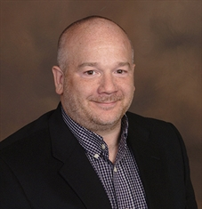Speaker: David Cushard, ChFC, CMFCDave is a 27 year veteran Financial Advisor based out of Jackson, MI, and the proud father of one of your DPT program peers at CMU.   Dave advises successful people all over the country.  Focusing on a relatable style of giving examples combined with facts, calculations and figures the goal is to deliver the message in the style and level that’s appropriate and to make it a comfortable environment to ask questions, get clarification and study alternatives.  Dave believes that ultimately, you achieving YOUR financial goals is the ONLY goal.

**Diastasis Rectus Abdominis: Principles over Protocols**

Are you familiar with the term Diastasis Rectus Abdominis? Do you know how to evaluate a person presenting with this diagnosis? Does it even matter? Are there times when DRA could be a good thing?

Popular media had done a great job of scaring the crap out of pregnant and postpartum women to the point that they are afraid to exercise in their pregnancy or enjoy everyday life with their new baby. By participating in this course, you are setting yourself up to be part of the solution. You will leave this course well informed on the anatomy of DRA. You will learn that your words matter and carry weight. You will learn some key assessment and treatment strategies. And perhaps, most importantly, you will be able to critically evaluate some of the common advice and limiting exercise programs that are out there.

Speaker: Emily Wilson PT, DPT

Emily Wilson is a Board Certified Women’s Health Physical Therapist and Owner of New Seasons Physical Therapy and Wellness located in Kalamazoo, MI. She is a 2010 graduate of Oakland University and has been fortunate to continue her education in some truly awesome courses over the past decade. Emily is an active member of the Michigan Physical Therapy Association. Currently she sits on the Communications Committee and was instrumental in the production of direct to consumer marketing videos. She is also the President of the Institute for Education and Research where she is chair of Grants. Emily has experienced a shift in her practice over the past few years that has made it truly a blast to go to work every day. She wants to share this with you as she presents on the topic of Diastasis Rectus Abdominis.

**Physical Therapy in the Emergency Center**

Physical Therapy (PT) in the hospital emergency department (ED) is a growing area of practice over the last five years. Development of a PT in the ED program requires continued partnership of the administration and physicians with the physical therapists. Physical therapists can help patients start on the road to recovery by providing early intervention in the injury process by facilitating the possibility to improve outcomes, reducing imaging, facilitating rehabilitation treatment throughout the continuum of care, and reducing hospital readmission. Patients receiving care by a PT in the ED benefit from the physical therapist’s expertise in musculoskeletal, neuromuscular, cardiopulmonary, vestibular, and chronic disease conditions.

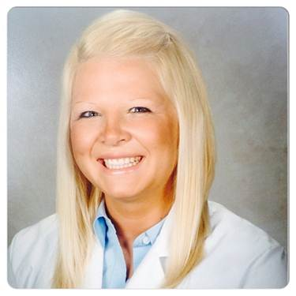

Speaker: Courtney Witczak, PT, DPT, GCS

Courtney graduated from the University of Michigan- Flint in 2009 with her Doctorate in Physical Therapy. In 2018, Courtney became APBTS Board Certified in Geriatrics from the American Physical Therapy Association (APTA). Courtney is also certified in Lee Silverman Voice Treatment (LSVT) for patients with Parkinson’s, American Heart Association Basic Life Support (BLS) instructor, and a APTA Advanced and Credentialed Clinical Instructor. Courtney is currently the APTA Michigan Oncology SIG Education Chair as well as an Oncology Mentor in the Beaumont Health APTA Oncology Rehab Residency. Courtney is an adjunct faculty at Wayne State University and performs guest lectures at various PT and PTA programs throughout the state of Michigan including University of Michigan-Flint, Oakland University, Macomb Community College, and Baker College. Courtney currently works as the Supervisor of Rehab Services at Beaumont Hospital, Troy overseeing the area of critical care medicine and emergency medicine. Courtney came to work at Beaumont Hospital in 2012 from the University of Michigan Health System. Courtney has served in various leadership roles within Beaumont such as Senior Physical Therapist, Clinical Coordinator of Education for Rehab Services, and Supervisor of Rehab Services since 2015. Courtney focuses her expertise and career goals on integrating evidence-based clinical research into the development of rehab practice protocols and management systems for optimal patient outcomes. Courtney’s clinical research focus is in physical therapy emergency medicine and intensive care mobilization of ventilated patients. Courtney’s management aspiration is to inspire frontline staff but mentoring side by side to empower employees to reach their full potential.

**­­­­­­­­­­Beyond Clinic Walls: Providing Practical Therapy in the Community**

“Give Life, Not Exercise”- Berta Botbath. This presentation will highlight innovative approaches to the provision of physical therapy interventions outside the traditional clinical setting, and actually within the natural environments where your patients need to function. Beyond Home Care, you will learn approaches to provide care that isn’t based on simulation, but on assessments and training in the locations with dynamic influencers that provide you, your patient, their families, physicians and case mangers an optimal level of vetting for genuine independence and integrity of discharge recommendations. Trans-disciplinary collaboration with other allied health professionals will also be reinforced to address the holistic needs and maximize client outcomes in TBI and other neurologic diagnosed populations. The difference between proving progress and meeting functional, criterion-based goals that prove preparedness will be presented. Learn how PT’s can use the environment to better train patients to anticipate and regulate errors and safety concerns. Case studies will be used to highlight these methods.

Steven R. Mandley, PT, CBIS
Speaker: Steven R. Mandley, PT, MPT, CBIS

Owner & Program Director of Rehab & Community Integration; Lead Therapist and Clinical Coordinator, at Rehab Without Walls. Steven has specialized in the field of brain injury rehabilitation since 1997, in acute care, inpatient rehab, home care, and community integration settings. He received his Masters in Physical Therapy at Oakland University in Rochester, Michigan. Steven was appointed to the Michigan Board of Physical therapy in 2002 and served as Chairman in 2006. As a program Surveyor with CARF International, Steven consults with rehab programs across the globe that specialize in Brain Injury rehabilitation. He has lectured on the emphasis of transference of skills in the community to healthcare professionals and students in the United States and Germany.